MORPH: objects into animals
Step 1: choose an object to draw, this could be something around you or from your memory. Then pick an animal that you think will go with it.
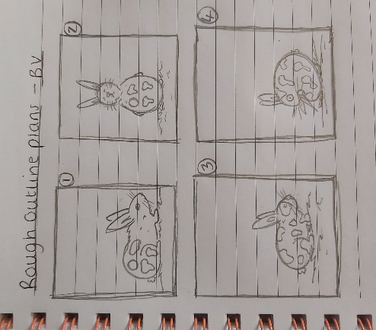
Examples: pencil into a dragonfly, watch/clock into a lion/cat/tiger face, key into a butterfly, lamp into an elephant face, cheese into a mouse, jellyfish into an umbrella, a book into a bird.
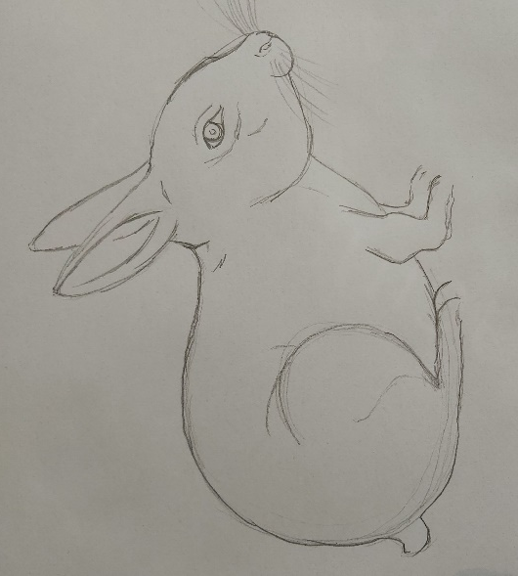
Step 2: decide on a plan of how to split the object and animal, what section is going to morph into the other. You may want to practice some rough outlines to get started.
Step 3: now you have chosen your layout and practiced, you are ready to draw the final outline up.
(once you chosen your template or completed your outline. I used a single HB pencil to shade my drawing, to show you don’t need lots of art materials to make good artwork.)
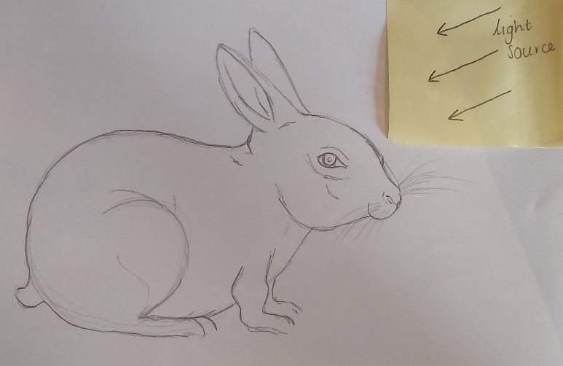
Step 4: at this step I chose to shade in my design with pencils if you would rather use colour feel free to do so. The following steps talk you through the shading process.
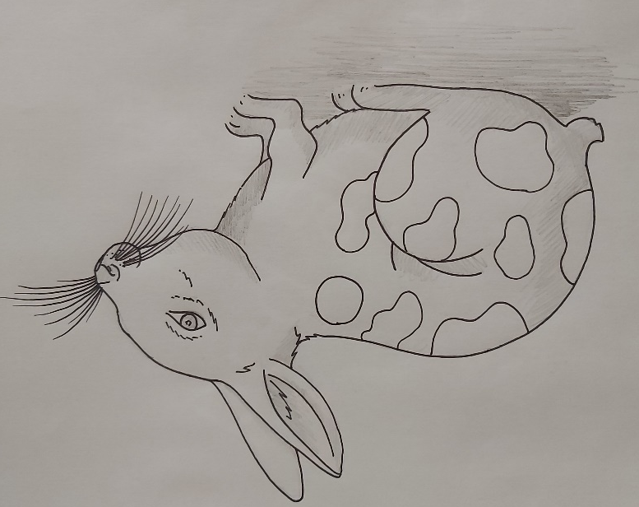
Step 5: chose which area your light source is coming from. The parts of the morphed object and animal closest to the light will be brighter. For these areas I like to leave the paper white.
Step 6: the areas further away from the light will be darker, I use a HB pencil to lightly mark the areas in the shadow. Use a light pressure at first, you want to build up the darkest parts rather than pressing down with the pencil hard. See the diagram for an idea of what you will be left with.

(if you have access to graded pencils e.g. 2B, 3B, HB, 2H, 3H then use these for shading, if not it is still possible to achieve the same gradient from light to dark.
- The softer pencils are the B grades, the lead is soft, blends easy and creates a darker line. Use these for the areas of your morphed object in shadow. The H graded pencils give a harsher, fine line and are good for fine details.
- To create a gradient from light to dark using just a HB pencil, apply different amounts of pressure to the pencil. When creating shadow apply more pressure to the pencil to create a darker line, for areas of light either leave the paper white or apply a small amount of pressure just to slightly cover the area. Don’t forget whether you use one HB pencil or a mixture of grades, you will want to go over areas to build up the shadow.)
Step 7: build up the darkest areas by shading again applying more pressure. Use the tips above to help you.
Step 8: now you want to blend the areas of shadow in with the light. To do this apply the most amount of pressure at the darkest side and gradually lighten the pressure you’re applying as you get to the lighter side. This creates a gradient effect from dark to light.
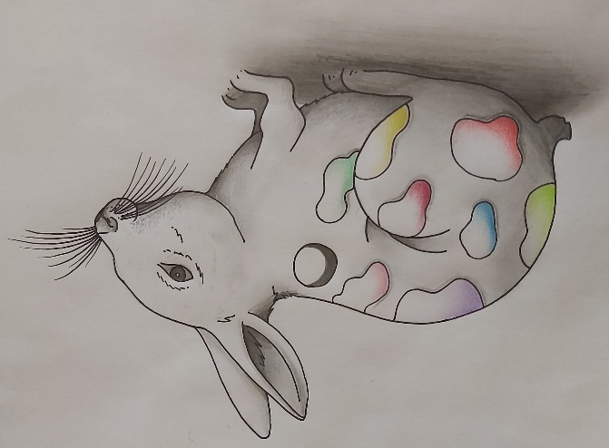
Step 9: keep building up the shadows, creating the same gradient effect as explained in step 8. You want to work on this until your happy with the drawing.
Step 10: if you have any fine details in your sketch e.g. patterns on butterfly wings, eyes, clock faces etc. work these into your drawing. Some parts may require shading for example, eyes, follow the steps again on a smaller scale. Work out where the light source is coming from the area closest to the light will be the white, then shade the darker areas of shadow. Following step 8 creating a blend between the light and dark sections.

